
STUDENT CASE STUDY EXECUTION REPORT
Department | FED
Subject | DSA -2
Academic year | I – III Semester(2025-26)
Faculty Name | Mohammed Razia Alangir Banu
Student Name | A Sai kiran
Roll Number | 2520030125
Branch | CSE
Course Outcome

Case Study Topic : FoodChain Logistics and Delivery routing system — Bidirectional Dijkstra
FoodChain is a large-scale restaurant and food delivery platform that connects restaurants, delivery hubs, warehouses, and customers through a city-wide logistics network.
To ensure fast and cost-effective deliveries, the FoodChain routing engine must determine the shortest and most efficient path between a restaurant and a customer location. The company wants to evaluate different shortest-path algorithms and compare their applicability across various graph structures such as weighted, unweighted, directed, undirected, and negative-weight graphs.
The logistics network is represented as a graph where:
- Vertices represent Restaurants, Delivery Hubs, Warehouses, Distribution Centers, and Customer Locations.
- Edges represent road connections.
- Edge weights represent travel distance, delivery time, or transportation cost.
The following algorithms are to be analyzed and implemented:
- Dijkstra's Algorithm
- Bidirectional Dijkstra's Algorithm
- Bellman-Ford Algorithm
- Floyd-Warshall Algorithm
The objective is to determine which algorithm performs best for different routing scenarios in the FoodChain Backend Restaurant & Delivery Index Management System.

Questions:

(a) Dijkstra's Algorithm
Run Dijkstra's Algorithm from Restaurant (RES) to Customer (CUS).
- Show the priority queue after each extraction.
- Find the shortest distance and shortest path.
- State the number of vertices explored before CUS is finalized.

(b) Bidirectional Dijkstra's Algorithm
Run Bidirectional Dijkstra with:
- Forward search from RES
- Backward search from CUS
Tasks:
- Maintain forwardDist[] and backwardDist[].
- Show alternating vertex extractions.
- Identify the meeting point.
- Find the shortest distance and path.
- Compare the number of vertices explored with standard Dijkstra.

(c) Algorithm Implementation and Comparison
Implement Bidirectional Dijkstra in Java for the FoodChain delivery network.

Implementation Process
- Model the FoodChain Network as a Graph
  - Represent restaurants, delivery hubs, warehouses, and customers as vertices and road connections as weighted edges.
- Implement Dijkstra's Algorithm
  - Use a priority queue to find the shortest delivery route from a restaurant to a customer.
- Implement Bidirectional Dijkstra
  - Perform simultaneous forward and backward searches to reduce the number of explored locations.
- Implement Bellman-Ford Algorithm
  - Calculate shortest paths and handle networks containing negative edge weights such as delivery discounts or promotional costs.
- Implement Floyd-Warshall Algorithm
  - Generate shortest paths between all pairs of locations for complete route planning across the FoodChain network.
- Compare Algorithm Performance
  - Evaluate execution time, path correctness, memory usage, and the number of vertices explored by each algorithm.
- Analyze and Select the Best Algorithm
  - Determine the most suitable algorithm for real-time delivery routing and logistics management in the FoodChain system based on the experimental results.

RESULT: Screenshot/Output
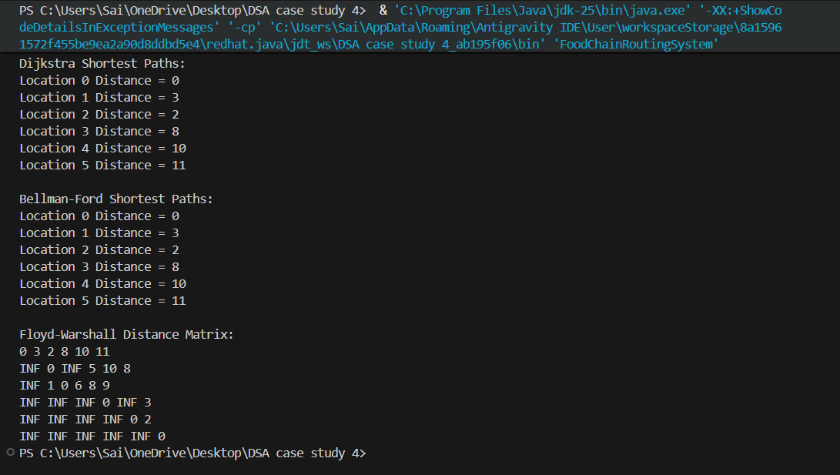
The Dijkstra's Algorithm, Bellman-Ford Algorithm, and Floyd-Warshall Algorithm were successfully implemented and analyzed on the FoodChain Backend Restaurant & Delivery Logistics Network. Dijkstra's Algorithm identified the shortest delivery route from Restaurant to Customer using positive edge weights.
- Bellman-Ford Algorithm successfully computed shortest paths and verified the absence of negative-weight cycles.
- Floyd-Warshall Algorithm generated the complete all-pairs shortest-path matrix for all locations in the delivery network.
Sample Shortest Distances Returned:
- Restaurant → Hub A = 3
- Restaurant → Warehouse = 8
- Restaurant → Dispatch Center = 10
- Restaurant → Customer = 11
- Hub B → Customer = 7

Time Complexity
- Dijkstra's Algorithm – O((V + E) log V)
- Bellman-Ford Algorithm – O(V × E)
- Floyd-Warshall Algorithm – O(V³)

GitHub Link: https://github.com/slashnight/DSA-2-case-study-assignment
Student Signature | Faculty Signature
____________________ | ___________________

